Given an n x n array of integers matrix, return *the* ***minimum sum*** *of any* ***falling path*** *through* matrix.

A **falling path** starts at any element in the first row and chooses the element in the next row that is either directly below or diagonally left/right. Specifically, the next element from position (row, col) will be (row + 1, col - 1), (row + 1, col), or (row + 1, col + 1).

**Example 1:**

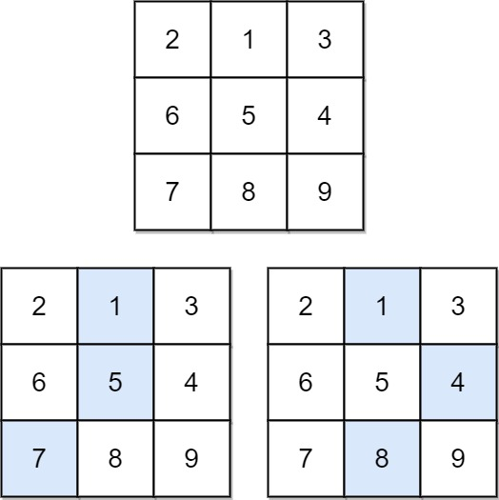

Input: matrix = [[2,1,3],[6,5,4],[7,8,9]]  
Output: 13  
Explanation: There are two falling paths with a minimum sum as shown.

**Example 2:**

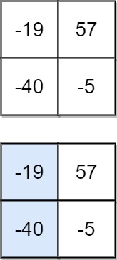

Input: matrix = [[-19,57],[-40,-5]]  
Output: -59  
Explanation: The falling path with a minimum sum is shown.

**Constraints:**

* n == matrix.length == matrix[i].length
* 1 <= n <= 100
* -100 <= matrix[i][j] <= 100